Lab-Network Configuration:  
1- show all connections

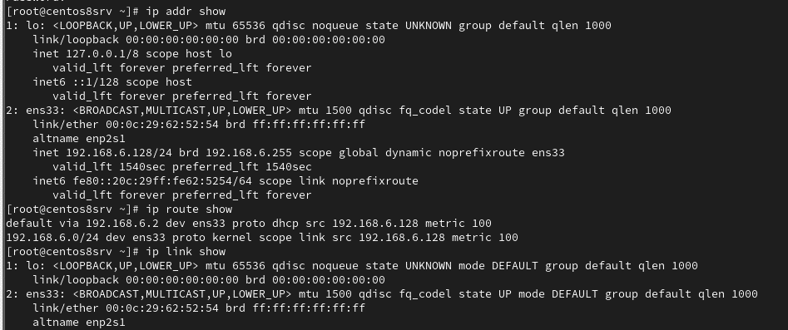

2- display all config setting for the active connection

3- show device status

4- display the setting of the eno16777736 interface

5- create a static connection with the same IP address, network, prefix and default gateway.  
Name the new connection static-eth0 with ip 172.25.0.11,netmask 255.255.255.0 and  
gateway 172.25.0.254

6- modify the new connection to add DNS

  
7- activate the new connection

  
8- view the active connection

9- verify the ip address using ip command

  
10- verify the default gateway

11- ping the DNS

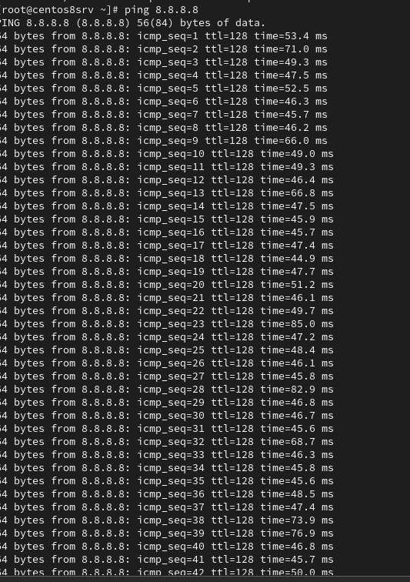

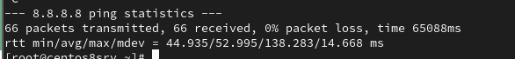

12- disable the original connection autostarting at boot

  
13- reboot the system

Reboot

14- view the active connections

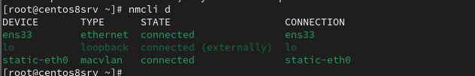­

17- display the current host name

18- display the host name status

19- change the hostname and hostname config file  


20- verify the configuration file providing the hostname at network start

